MID-Atlantic Rhododendron News and Notes Volume 51 No. 1
MAC SPRING MEETING, April11-12, 2025
DoubleTree by Hilton Norfolk Airport, 1500 North Military Highway, Norfolk, VA
Our Chapter Spring Meeting will beheld on Friday evening April 11 and Saturday April 12. Two speakers are scheduled to address our group. Friday evening after a dinner buffet, Theresa Augustin, Vice-President of Education, Norfolk Botanical Garden will share the history, present workings of the botanical garden and future plans for the garden. Theresa was beginning her career at NBG and assisted in the planting of the McDonald Azalea Collection as well as deciduous azaleas, species and hybrids, from Sandra and the late Kenneth McDonald's LeMac Nurseries.
Saturday morning, MAC will have its chapter meeting. Among meeting topics will be: nominations for President, Vice-President, Board Members for terms expiring 2028. Afterwards we will carpool
2.6 miles to (and from) the Tidewater Arboretum at the Virginia Tech Ag Research Center. We will be greeted and accompanied by two representatives of the facility. The first garden visited will bethe BayScape Garden and this is the largest collection of native plants at the Center. The second garden will be the Perennial Theme Garden which also contains native perennials, ornamental shrubs and garden features.
After lunch, we will carpool 2.5 miles to (and from) the Norfolk Botanical Garden for a group tram tour and ample time to walk areas of the Botanical Garden. MAC has been a long-standing donor to the garden and collections from Sandra and Ken McDonald are part of the landscape.
To finish the afternoon, a plant auction and plant sale will be conducted. 70 or more companion plants will beoffered as part of the plant sale. Some varieties will include Twinleaf, Bloodroot, Virginia Bluebells, Sessile Trillium, ferns, Lenten Rose, Siberian Iris, Wild and European Ginger, Alum Root, and Foamflower. At the fall 2024 meeting these plants were "sold" asa donation only. That seemingly worked well.
After a dinner buffet, our speaker will be Sally Perkins. Sally, a member of the Massachusetts Chapter, is no stranger to our chapter. She will share "30 Years of Rhododendrons" with us.
Sunday morning is breakfast on your own. Two post meeting stops will be available Sunday morning with details to be provided by David Taylor at the meeting.
One stop will be the gracious invitation to visit the David and Joan Taylor Garden in Yorktown VA just minutes off 1-64 and the York Learning Garden and Arboretum in the same vicinity.

Registration forms will be mailed to members as well as appearing on the chapter website. www.macars.org Registration includes Friday dinner buffet (Baked Salmon, Citrus Basil Pork), Saturday breakfast buffet, lunch buffet, dinner buffet (Beef Tenderloin, Mediterranean Chicken Breast), admission to and tram tour of Norfolk Botanical Garden, meeting programs and meeting activities.
Questions may be directed to and registration forms and schedule may be requested from Doug Jolley, President at the following email. aplectrumwv@yahoo.com

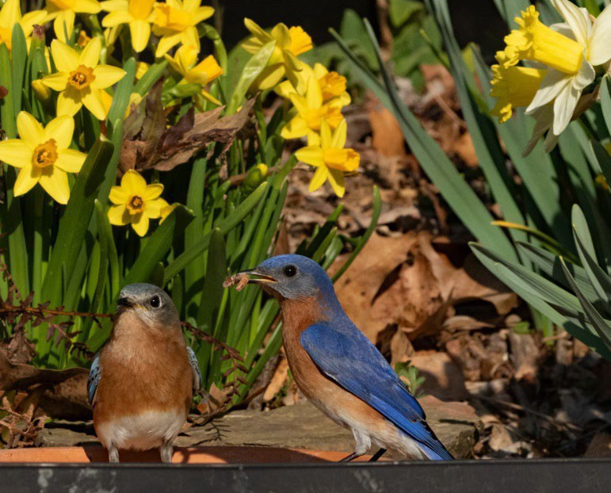
Bluebirds and early daffodils
Windbeam Way Wanderings March 2025 by Doug Jolley
The garden highlight of early 2025 has been a trip to visit the Massachusetts Chapter for a presentation. The morning before the meeting my host Joe Bruso gave me a tour of his 10 acres of rhododendrons. What a genetic smorgasbord! There are plants ranging from decades old to weeks old. One characteristic Joe looks for is foliage and there was an abundance of leaf shapes, sizes and textures. Some areas of old growth rhododendrons have created their own “Rhododendron Hells” or impenetrable thickets. Through this, Joe has pruned out tunnels to allow for easy access through these areas to other parts of the garden! Also, mixed throughout the garden are a variety of deciduous azaleas, kalmias and magnolias.
The arrival of warmer temperatures here in central West Virginia was signaled not by the thermometer but by oriental witch hazels coming into bloom. The

Images from Joe’s Garden

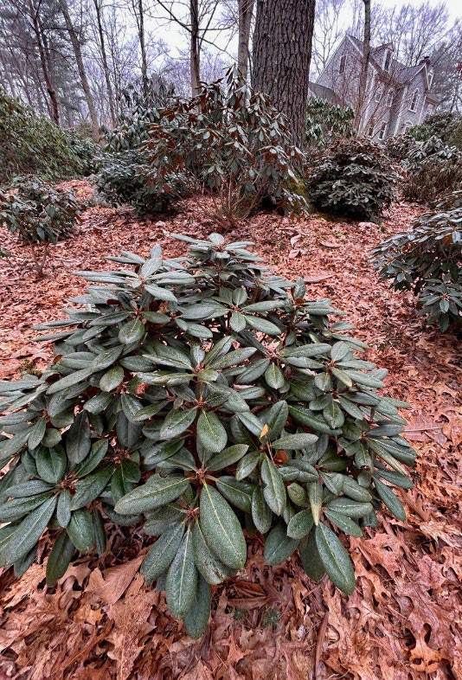
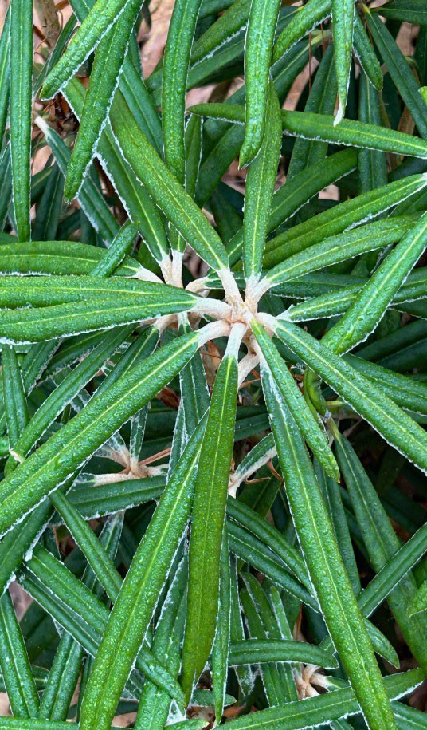

Rhododendron makinoi
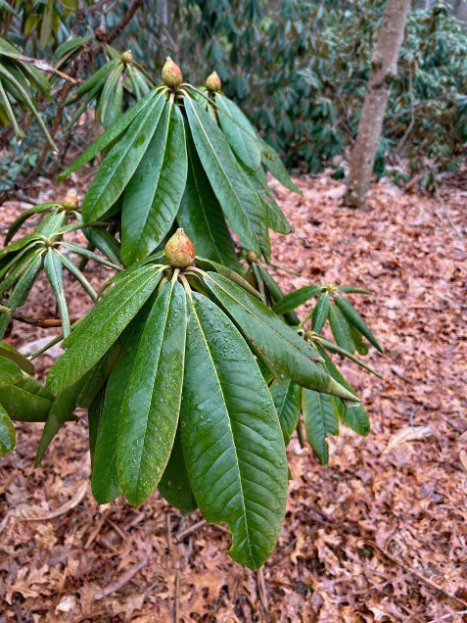

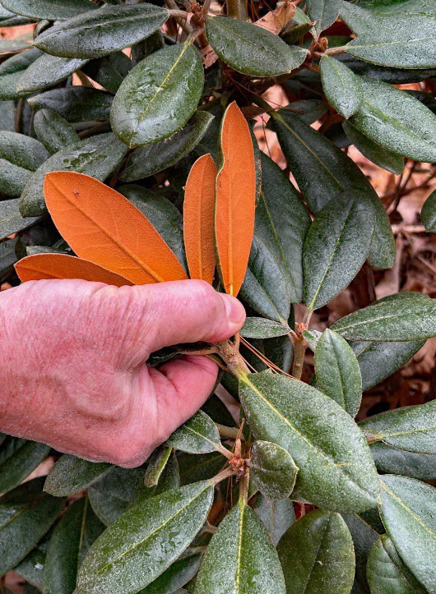
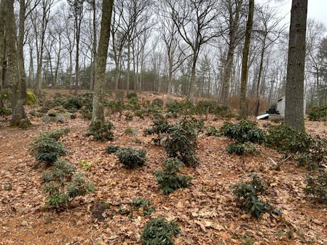

Younger Plantings
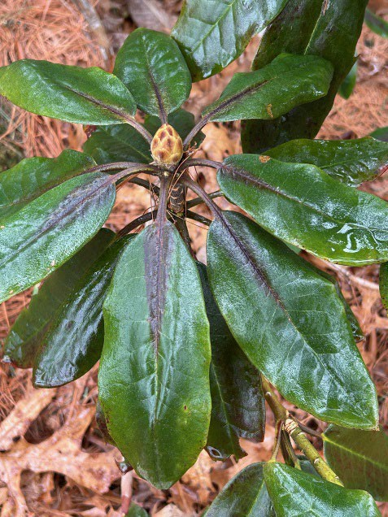
Red Maximum effect on foliage
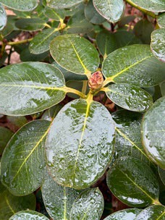
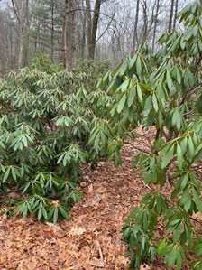

Mature Plantings

message to the olfactory senses is immediate. Later cold snaps, snow or what have you do not impair the ﬂowers of these great companions.
This winter, we experienced multiple days with below zero temperatures, lots of snow cover (one storm dropped 13 inches) and lots and lots of wind. With an early chapter meeting this spring, Davetta and I will be able to enjoy a blooming season interrupted only by tending to collapsed shade structures and sessions of tree limb and branch pickup!
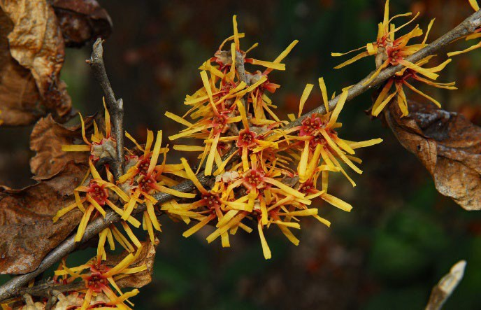
1 Oriental Witch hazel

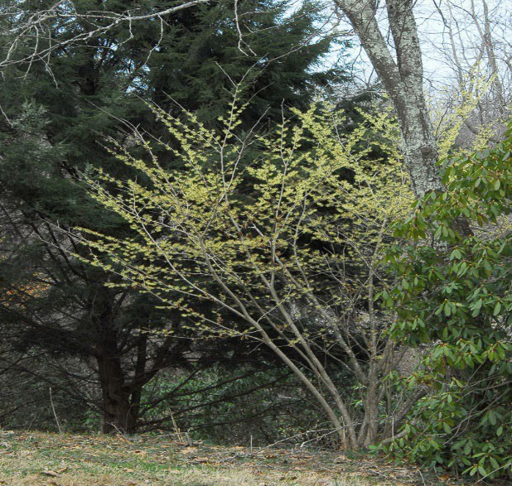
Oriental Witch Hazel 'Luna

MAC OFFICERS
GARDENS OPEN TO NEW MEMBERS – New members are encouraged to visit members’ gardens in their area. The officers and board members have agreed to show new members through their gardens if the member will call ahead and arrange a convenient time. Telephone numbers and towns are listed below.
MIDDLE ATLANTIC CHAPTER OFFICERS AND DIRECTORS
President Doug Jolley 304-765-1064 Heaters WV aplectrumwv@yahoo.com
Vice-President Theresa Brents 540-337-1389 Stuarts Draft VA tbrents@gmail.com Secretary Jeanne Hammer 434-989-1307 Macon NC jeannehammer@gmail.com Treasurer Debbie Sauer 804-530-1111 Chester VA ddsauer@gmail.com Membership Jeanne Hammer 434-989-1307 Macon NC jeannehammer@gmail.com Directors:
EXP 5/24 William Bedwell 804-469-3521 Dinwiddie VA wbedwell@verizon.net Sandra McDonald 757-723-5612 Hampton VA sfmcdonald@verizon.net Lloyd Willis 804-823-2177 Crozet VA lwillis@pvcc.edu
EXP 5/25 David Banks 757-561-9444 Williamsburg VA dfbanks@earthlink.net Hubert Barb 540=856-8592 Bayse VA homeplaceii@msn.com
EXP 5/26 David Taylor 757-898-8321 Yorktown VA 12.buckle.my.shoe.@verizon.net George McLellan 804-694-7864 Gloucester VA gmclellan38@gmail.com
Sharon Horn 540-350-2666 Mt. Solon VA hi.meadows.farm@gmail.com
Past President Theresa Brents 540-337-1389 Stuarts Draft VA tbrents@gmail.com Newsletter Editor Doug Jolley 304-765-1064 Heaters WV aplectrumwv@yahoo.com District 9 Director Richard Mohr 301-983-3075 Potomac MD
Alternate Director Lloyd Willis 804-823-2177 Crozet VA lwillis@pvcc.edu
Membership and renewals should be sent to: MAC Membership, Jeanne Hammer, 231 N Robinson Dr, Macon, NC 27551 Annual Membership Dues are $40.00 per year Miscellaneous inquiries may be sent to the newsletter editor for forwarding to proper individual.

