MID-ATLANTIC CHAPTER
RHODODENDRON
NOTES AND NEWS
Volume 51 No. 2
MAC Spring Meeting 2025 Norfolk, VA
The Spring Meeting of the Middle Atlantic Chapter ARS was held Friday evening and Saturday, April 11 and 12, 2025 at the DoubleTree by Hilton Norfolk Airport, Norfolk, VA. 21 members and associates registered for the meeting.
Following the Friday evening buffet our evening speaker was Theresa Augustin, VP of Education, Norfolk Botanical Garden. Theresa began her career at the Garden when the McDonald azaleas and other native azaleas were being planted, and she continues to be very active in that portion of the Garden. Theresa shared the history of NBG and current highlights and scenes from the entire grounds.
The MAC Chapter Meeting was opened by President Doug Jolley. Lloyd Willis, Nominating Committee Chair, presented the following nominations for 3-year MAC Board of Director positions 2025 - 2028: Dave Banks and Ben Dukes. The nominations were unanimously approved.
Next, Lloyd presented the following nominations for 2-year offices 2025 – 2027: Secretary, Jeanne Hammer, Treasurer, Debbie Sauer, Vice-President, Theresa Brents and President, Doug Jolley. The nominations were unanimously approved.
The morning garden tour was to the nearby Tidewater Arboretum. The Virginia Tech Master Gardeners maintain themed gardens and we were met and accompanied by one of the master gardeners through the various themed gardens. The gardens visited are on the grounds of the Virginia Tech Ag Research Center and include the Bayscape Garden consisting of Tidewater native plants and the Perennial Theme Garden with its Children’s Garden and Garden Follies, ornamental shrubs, perennials and other garden features.
After lunch, attendees travelled to the Norfolk Botanical Garden. We had over an hour to walk on the grounds on our own and then we finished with a 35 minute tram tour of the Garden. Also, an African Violet show and sale was ongoing as well and a well-appointed gift shop were in the Visitor’s Center. Most of everyone made their way to the rhododendron and azalea area and one of the prominent features was the McDonald Azalea Collection. Overall, the garden was in prime bloom. Norfolk Botanical Garden indeed provided a wonderful afternoon experience.
A companion plant sale and plant auction concluded the afternoon. Many thanks to Barbara and Alton Hall, George McLellan and Doug and Davetta Jolley for the plant sale and auction offerings!
After a supper buffet, our evening speaker was Sally Perkins. A member of the Massachusetts Chapter ARS, Sally (and husband John) is no stranger to our chapter. She shared “30 Years of Rhododendrons” which included decades of rhododendron and azalea growing, exploring and enjoying gardening highlights.
Heartfelt thanks go out to the staff at the hotel, Mike Andruczyk (Va Tech), Ben Dukes (local information) and garden staff at our garden venues and speakers. The hotel staff made planning the meeting a breeze with meals, transportation to and from our venues and overall hospitality. Also, thanks to Theresa Brents and Debbie Sauer for meeting planning and treasurer assistance and to Nominations Chair Lloyd Willis. And, Thank You Attendees.
MAC Spring Meeting 2025 post meeting tours
During the Spring Meeting, Barbara and Alton Hall invited attendees to stop by to visit their Gloucester, VA garden and David Taylor also invited attendees to stop by his and Joan’s Yorktown, VA garden. David also highly recommended a stop near to his home, York Learning Garden. All three venues were worthwhile and most enjoyable.
One of the circulars available at York Learning Garden included a narrative about the formation of the Learning Garden. Longtime MAC member, the late Sybil Przypek “led the establishment of the Learning Garden in 1994…” The circular goes on to note that “plants were obtained from azalea and rhododendron hybridizers, such as LeMac Nursery…” The handout concludes that “The Garden’s wonderful springtime show by the azaleas are a continuing tribute to Sybil.”
The YLG is a compact area with walking paths and rhododendrons, azaleas and companions in abundance. Plants were in full regalia the morning of Davetta and my visit.
Just after arriving at David and Joan Taylor’s waterside property, Don Hyatt arrived, and we had a tour with David of his garden. This was a wonderful setting for rhododendrons and azaleas and more.
On to Gloucester to visit Barbara and Alton Hall. Not only is their garden home to rhododendrons and azaleas (many of which were in prime bloom), but the array of companion plants and a beautiful water feature was wonderful. I had not seen Goldenclub since a late 1900’s trip to a mountain bog and there it was in the water feature in full regalia!
Again, many thanks to the Hall’s and Taylor’s for a terrific Sunday morning send off!
Windbeam Way Wanderings May 2025 by Doug Jolley
An article appeared in a recent issue of the Journal of the ARS. The topic addressed drought tolerant rhododendrons. One of those listed was Rh. Edith Pride. Orlando Pride Nurseries is located just south of Butler, PA and Orlando Pride hybridized noteworthy azaleas and rhododendrons for decades. I travel in and through the general area reasonably often but never had time to stop. Pride Nurseries now specialize in hollies. The website does list a very small number of rhododendrons including ‘Edith Pride’. Given that information I traveled to the nursery for a visit to see if any offerings of it and others would be suitable as chapter auction plants. The current owner Charlie Hinchberger noted that the reduction in azalea and rhododendron offerings was largely due to the heavy urban deer population in his area and thus a move to hollies was made. Pride Nurseries have multiple fields under cultivation, and we drove to see the rhododendron field. Hopefully I will be bringing Rh. Edith Pride, a vintage Pride Rh. Yak selection and Rh. Pioneer Silvery Pink to the fall meeting.
Along the way to the field, a home appeared in the distance. The grounds were the kaleidoscope of bloom suggesting a rhododendron enthusiast. My host informed me that it belonged to Gordon and Kay Walters. I directed that we pull in and see if we could visit for a moment. Charlie had never met the couple, and I knew the name from years of associate membership (Gorden is membership chair) in the Great Lakes Chapter ARS. After the introductions, we had a great visit with the Walters and the highlight for me was three rhododendrons growing together. I have a Rh. Mist Maiden that is nearly six feet tall. Well, Gordon (aka Spike) showed me Rh. Mist Maiden, Ken Janeck and Yakity Yak growing together, all plants over ten feet tall!
Finally, a circular obtained at the York Learning Garden by Virginia Tech Cooperative Extension lists Rh. Edith Pride in its list of rhododendrons suitable for heat and drought tolerance. This plant should be suitable for the entire MAC area.
Here in West Virginia, our spring season has been outstanding. We experienced our last frost in mid-April. This affected the few early rhododendrons a bit but a frost-free spring with ample rainfall and overall pleasant temperatures has allowed everything to bloom for weeks on end. Some highlights will be in pictures!
In the Crozet Garden Lloyd Willis
It is Thursday, February 27, 2025 as I sit down to start this article. After about four weeks of no walking in the garden, Margaret and I have been able to have those morning walks this week. We stopped the garden walks when six inches of snow turned into a six inch layer of ice. It was too dangerous to walk even with our hiking poles. It took three weeks of ice melting to even think about starting to walk in the garden again. Then, after a couple of days of returning to morning walks, we had 20 to 30 mile per hour winds with gusts of 55 to 60 mph. The wind gusts brought down hundreds of twigs and limbs but thankfully no trees this time. It took me two hours to clean up the yard of the friends who live in the house north of us. They are gone on a trip and will come back to a neater yard. Soon I will start on the yard south of them (ours) which has even more limbs and twigs down.
What happened in the three weeks that we were not walking in the garden? We had an infestation of deer—maybe make that hungry lazy deer. The deer used our cleared driveway as a path to eat the first two or three inches of the azaleas at the driveway’s edge. The deer also managed to taste most of the azaleas in the whole garden. In the side garden, the deer ate only the terminal buds on some rhodos and only leaves on other rhodos. Some rhodos had broken limbs but the terminal buds and leaves were untouched. The deer did not bother the rhodos which were over ten feet tall.
Time to be positive. What did I find of positive interest in the garden? That would be the hundreds of yellow, white, and purple snow crocus which are in bloom. They look quite nice and look even better in contrast to the brown mulch and the dwarf mondo grass. Yesterday, one of the currently leafless Japanese maples looked almost white on the upper half. When I got closer, I could see it was the dead white branches from this past season’s growth. But, if you like bright white, it was a treat. Also, yesterday we saw some dark purple blooms on one of the hellebores in a bed around a Japanese maple. The American boxwoods in our front yard made a wonderful contrast with the brown of the rest of the yard.
So, where is the humor in this article? I am making plans for my yard work helpers when they are on spring break this March. This is my progress so far: 1) My spring break helper for six years plans to do a road trip to all the state parks in Texas over spring break. He will not be available. 2) One grandson helper plans to do a road trip over spring break. He drives and his buddy pays for the gas. He will not be available. 3) Another grandson helper plans to visit his girlfriend over spring break. He will not be available. and, 4) The granddaughter helper will most likely be working mostly with her Gramma Margaret over spring this is funny.
Native Azaleas along the VA WV divide
MAC member David Wheeler of Hot Springs, VA shared some native azalea highlights from a trail running along the Bath County VA and Pocahontas County WV line. It appears that some natural hybridizing (Rh. Calendulaceum and Rh. Periclymenoides) is occurring in that area.
Photos by David Wheeler
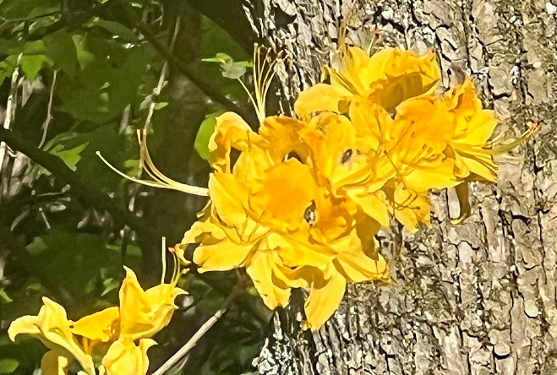
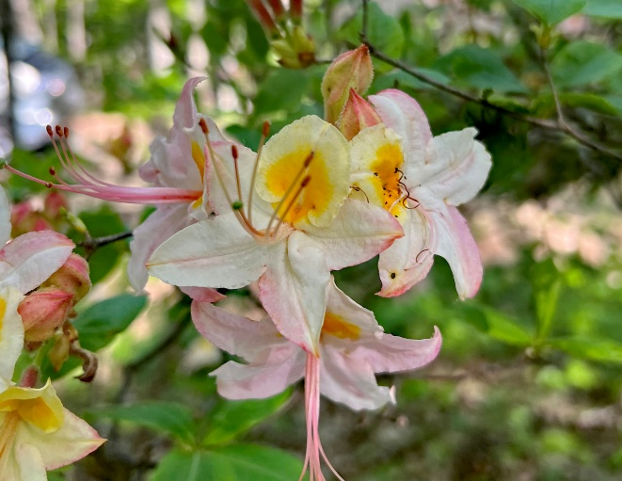
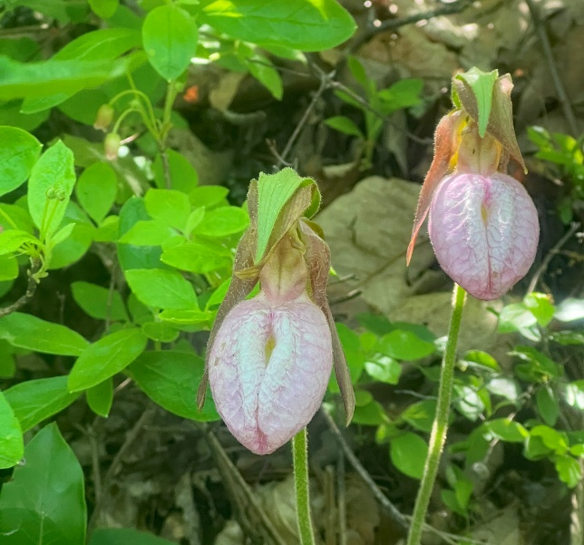

Spring Meeting Photos by Doug Jolley
Tidewater Arboretum - Virginia Tech
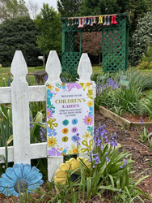
Children’s Garden
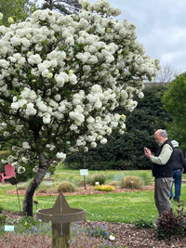
MAC member David Wheeler
Norfolk Botanical Garden
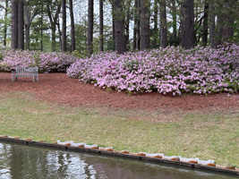
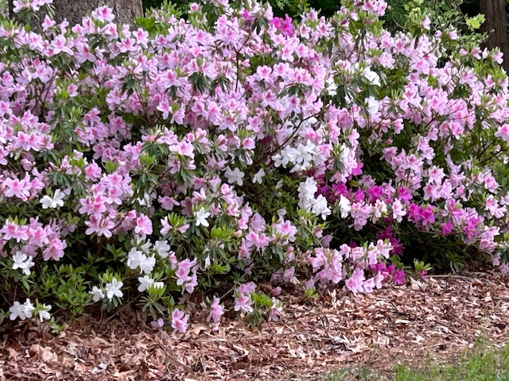
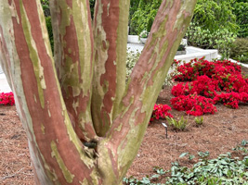
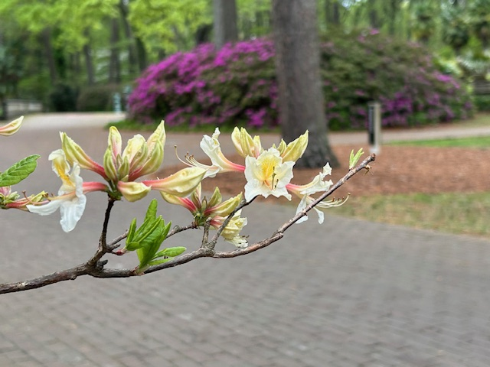
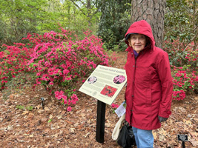
MAC member Sandra McDonald
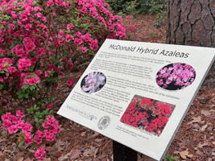

Alton and Barbara Hall garden
Photos by Doug Jolley
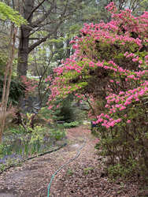
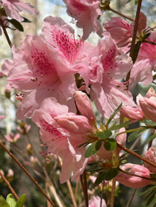
David and Joan Taylor Garden
Photos by Doug Jolley
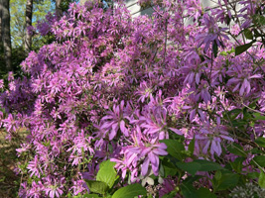
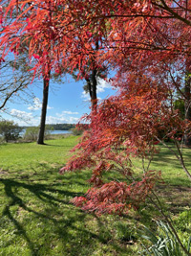
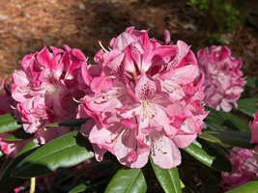
York Learning Garden: D Jolley
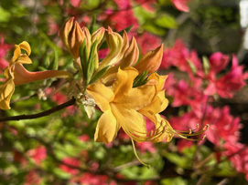
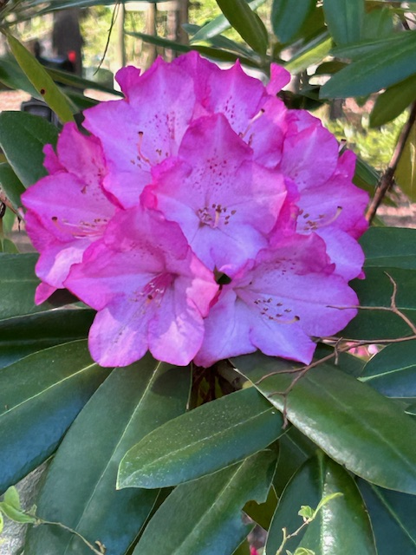
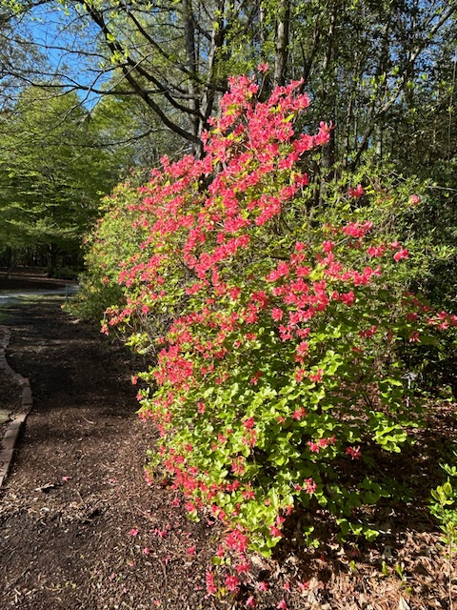
Windbeam Way Wanderings: D Jolley
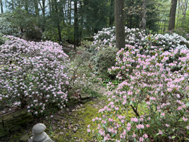
Gordon and Kay Walters’ garden
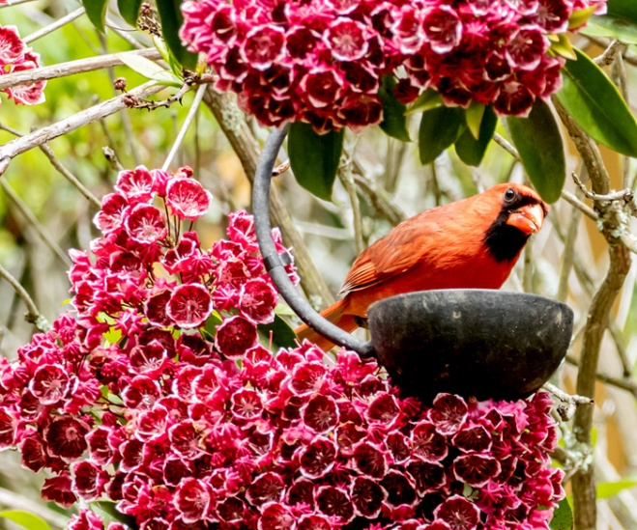
Cardinal and Mt. Laurel, Jolley Garden
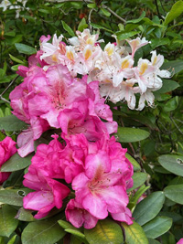
Ed Reiley rhodo, Frank Pelurie azalea

MAC OFFICERS
GARDENS OPEN TO NEW MEMBERS – New members are encouraged to visit members’ gardens in their area. The officers and board members have agreed to show new members through their gardens if the member will call ahead and arrange a convenient time. Telephone numbers and towns are listed below.
MIDDLE ATLANTIC CHAPTER OFFICERS AND DIRECTORS
Officers with Terms Expiring 2027
President Doug Jolley 304-765-1064 Heaters WV aplectrumwv@yahoo.com
Vice-President Thersea Brents 540-337-1389 Stuarts Draft VA tbrents@gmail.com
Secretary Jeanne Hammer 434-989-1307 Macon NC jeannehammer@gmail.com
Treasurer Debbie Sauer 804-530-1111 Chester VA ddsauer@gmail.com
Membership Jeanne Hammer 434-989-1307 Macon NC jeannehammer@gmail.com

Directors:
EXP5/26
DavidTaylor757-898-8321YorktownVA 12.buckle.my.shoe.@verizon.net
George McLellan 804-694-7864 Gloucester VA gmclellan38@gmail.com
Sharon Horn 540-350-2666 Mt. Solon VA hi.meadows.farm@gmail.com
EXP 5/27 Laurel Hill Mechanicsville, VA laurel.hill@vadot.virginia.gov
Sandra McDonald 757-723-5612 Hampton VA sfmcdonald@verizon.net
Lloyd Willis 804-823-2177 Crozet VA lwillis@pvcc.edu
EXP 5/28 David Banks 757-561-9444 Williamsburg VA dfbanks@earthlink.net
Ben Dukes Portsmouth, VA bendukes73@gmail.com
Past President Doug Jolley
Newsletter Editor Doug Jolley 304-765-1064 Heaters WV aplectrumwv@yahoo.com
District 9 Director Lloyd Willis 804-823-2177 Crozet VA lwillis@pvcc.edu
Alternate District Director John Lawson

Membership and renewals should be sent to: MAC Membership, Jeanne Hammer, 231 N Robinson Dr, Macon, NC 27551
Annual Membership Dues are $40.00 per year

